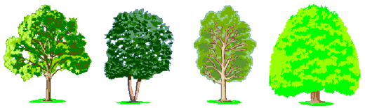
Hawthorn Road
Lache
Chester
Cheshire
CH4 8HX
Tel: 01244 981333
Website: www.lache.cheshire.sch.uk
Email:
admin@lache.cheshire.sch.uk

‘Live to Learn, Learn to Live’

Headteacher: Mrs Kate Seager

Remote Learning Key Stage 1

Dear parents/carers,

Due to last night’s announcement we will now be moving to remote learning and this will be set up and ready to access by the end of this week. Government expectations are that all pupils engage with remote learning over the coming weeks and provide evidence of this to their class teacher on a daily basis. We will use the Seesaw app to do this and it is crucial that everybody has the app and is accessing the work that has been set. We realise at first that there may be some technical issues and teachers are here to help with that (please contact us via Weduc). Seesaw is a very easy app to use and the children are familiar with it.

Each day class teachers will set tasks/activities for the following subjects:

- Maths
- Literacy
- Reading / Bug Club
- Phonics
- 4 a day
- Topic/Science
- PE

The children will be expected to complete all the tasks that are set as they would if they were in school. When they have completed their work they need to share it with us by sending us a photo of it on the seesaw app. For some of the activities, such as online games, they can simply comment to let us know that they have done it. We will be making a record of the activities that children complete and will be contacting any parents/carers whose child is not engaging with remote learning. Alongside these curriculum tasks and activities we will also post some fun things which the children might enjoy doing in their spare time and will help with their wellbeing. We really do look forward to seeing the children’s work and being in touch with them every day!

We realise that this is a very difficult time and appreciate your support with this. We are all in this together and we are here for your children. Please contact us via Weduc if you need support with anything.

Many thanks,

Karen Lloyd
KS1 Lead

